**Food**

**Find the tentative model**

**Estimates at Each Iteration**

|  |  |  |  |  |
| --- | --- | --- | --- | --- |
| **Iteration** | **SSE** | **Parameters** | | |
| 0 | 166.036 | 0.100 | 0.100 | 0.100 |
| 1 | 110.065 | 0.250 | 0.036 | 0.073 |
| 2 | 96.300 | 0.175 | -0.114 | 0.021 |
| 3 | 91.115 | 0.325 | 0.012 | 0.047 |
| 4 | 82.876 | 0.475 | 0.122 | 0.070 |
| 5 | 71.857 | 0.625 | 0.211 | 0.095 |
| 6 | 60.412 | 0.775 | 0.279 | 0.129 |
| 7 | 52.228 | 0.925 | 0.337 | 0.183 |
| 8 | 50.392 | 1.005 | 0.395 | 0.245 |
| 9 | 50.180 | 1.003 | 0.422 | 0.259 |
| 10 | 50.156 | 1.002 | 0.426 | 0.262 |
| 11 | 50.152 | 1.001 | 0.426 | 0.262 |

*Relative change in each estimate less than 0.001*

**Back Forecasts (After Differencing)**

|  |  |  |  |  |  |  |  |  |  |
| --- | --- | --- | --- | --- | --- | --- | --- | --- | --- |
| Lag | (-97, -90) | -1.115 | -1.114 | -1.112 | -1.110 | -1.109 | -1.107 | -1.105 | -1.104 |
| Lag | (-89, -82) | -1.102 | -1.100 | -1.099 | -1.097 | -1.096 | -1.094 | -1.092 | -1.091 |
| Lag | (-81, -74) | -1.089 | -1.087 | -1.086 | -1.084 | -1.083 | -1.081 | -1.079 | -1.078 |
| Lag | (-73, -66) | -1.076 | -1.075 | -1.073 | -1.071 | -1.070 | -1.068 | -1.067 | -1.065 |
| Lag | (-65, -58) | -1.064 | -1.062 | -1.060 | -1.059 | -1.057 | -1.056 | -1.054 | -1.053 |
| Lag | (-57, -50) | -1.051 | -1.049 | -1.048 | -1.046 | -1.045 | -1.043 | -1.042 | -1.040 |
| Lag | (-49, -42) | -1.039 | -1.037 | -1.036 | -1.034 | -1.032 | -1.031 | -1.029 | -1.028 |
| Lag | (-41, -34) | -1.026 | -1.025 | -1.023 | -1.022 | -1.020 | -1.019 | -1.017 | -1.016 |
| Lag | (-33, -26) | -1.014 | -1.013 | -1.011 | -1.010 | -1.008 | -1.007 | -1.005 | -1.004 |
| Lag | (-25, -18) | -1.002 | -1.001 | -0.999 | -0.998 | -0.996 | -0.995 | -0.993 | -0.992 |
| Lag | (-17, -10) | -0.991 | -0.989 | -0.988 | -0.986 | -0.985 | -0.983 | -0.982 | -0.980 |
| Lag | (-9, -2) | -0.979 | -0.977 | -0.976 | -0.975 | -0.973 | -0.972 | -0.970 | -0.969 |
| Lag | (-1, 0) | -0.967 | -1.089 |  |  |  |  |  |  |

**Back Forecast Residuals**

|  |  |  |  |  |  |  |  |  |  |
| --- | --- | --- | --- | --- | --- | --- | --- | --- | --- |
| Lag | (-97, -90) | 0.003 | 0.005 | 0.006 | 0.007 | 0.008 | 0.009 | 0.009 | 0.009 |
| Lag | (-89, -82) | 0.010 | 0.010 | 0.010 | 0.010 | 0.010 | 0.010 | 0.010 | 0.010 |
| Lag | (-81, -74) | 0.010 | 0.010 | 0.010 | 0.010 | 0.010 | 0.010 | 0.010 | 0.010 |
| Lag | (-73, -66) | 0.010 | 0.010 | 0.010 | 0.010 | 0.010 | 0.010 | 0.010 | 0.010 |
| Lag | (-65, -58) | 0.010 | 0.010 | 0.010 | 0.010 | 0.010 | 0.010 | 0.010 | 0.010 |
| Lag | (-57, -50) | 0.010 | 0.010 | 0.010 | 0.010 | 0.010 | 0.010 | 0.010 | 0.010 |
| Lag | (-49, -42) | 0.010 | 0.010 | 0.010 | 0.010 | 0.010 | 0.010 | 0.010 | 0.010 |
| Lag | (-41, -34) | 0.010 | 0.010 | 0.010 | 0.010 | 0.010 | 0.010 | 0.010 | 0.010 |
| Lag | (-33, -26) | 0.010 | 0.010 | 0.010 | 0.010 | 0.010 | 0.010 | 0.010 | 0.010 |
| Lag | (-25, -18) | 0.010 | 0.010 | 0.010 | 0.010 | 0.010 | 0.010 | 0.009 | 0.009 |
| Lag | (-17, -10) | 0.009 | 0.009 | 0.009 | 0.009 | 0.009 | 0.009 | 0.009 | 0.009 |
| Lag | (-9, -2) | 0.009 | 0.009 | 0.009 | 0.009 | 0.009 | 0.009 | 0.009 | 0.009 |
| Lag | (-1, 0) | 0.009 | -0.114 |  |  |  |  |  |  |

**Final Estimates of Parameters**

|  |  |  |  |  |
| --- | --- | --- | --- | --- |
| **Type** | **Coef** | **SE Coef** | **T-Value** | **P-Value** |
| AR   1 | 1.0015 | 0.0537 | 18.64 | 0.000 |
| MA   1 | 0.426 | 0.162 | 2.63 | 0.012 |
| MA   2 | 0.262 | 0.157 | 1.66 | 0.104 |

Differencing: 0 regular, 1 seasonal of order 12

Number of observations:  Original series 60, after differencing 48

Diagnostic checking

1. Significance of the parameters
2. Residual Analysis : Randomness and Normality
3. Significance of the parameters

H0 : all coefficient = 0

H1 :  all coefficient ≠ 0

5% significance level

If the p-value < 0.005 , null hypothesis is rejected

If the p- value > 0.005 , null hypothesis is not rejected

Since, p-value of MA(2)>0.05 , null hypothesis is not rejected and it is insignificant. Therefore, we have to revise the model by removing insignificant coefficients.

1st revised model

**Final Estimates of Parameters**

|  |  |  |  |  |
| --- | --- | --- | --- | --- |
| **Type** | **Coef** | **SE Coef** | **T-Value** | **P-Value** |
| AR   1 | 0.8923 | 0.0934 | 9.56 | 0.000 |
| MA   1 | 0.228 | 0.184 | 1.23 | 0.223 |

2nd revised model

**Final Estimates of Parameters**

|  |  |  |  |  |
| --- | --- | --- | --- | --- |
| **Type** | **Coef** | **SE Coef** | **T-Value** | **P-Value** |
| AR   1 | 0.8057 | 0.0898 | 8.97 | 0.000 |

Since p-value of AR(1)<0.05, null hypothesis is rejected and it implies that all coefficients are significant.

Finally revised model is : SARIMA(1,0,0)(0,1,0)12

1. Residuals Analysis : Randomness and Normality

|  |  |
| --- | --- |
| Randomness of residuals | Normality of residuals |
| Ljung Box | Histogram |
| Residual ACF & PACF | Normal Probability Plot |
| Hypothesis:  H0 : Residual ACF = 0  H1 : Residual ACF ≠ 0  p-value > 0.05, Then H0 is not rejected and residual are random |  |

**Modified Box-Pierce (Ljung-Box) Chi-Square Statistic**

|  |  |  |  |  |
| --- | --- | --- | --- | --- |
| **Lag** | **12** | **24** | **36** | **48** |
| Chi-Square | 12.63 | 20.66 | 29.68 | * |
| DF | 11 | 23 | 35 | * |
| P-Value | 0.318 | 0.602 | 0.723 | * |

Since all the p-values for lag

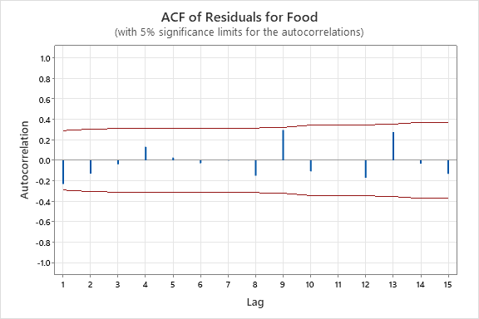

Normal Probability of Residuals

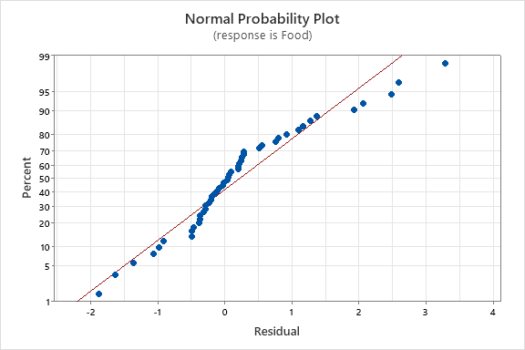

Since there is an approximate straight line in normal probability plot, residuals can be considered as normal

Histogram for residuals

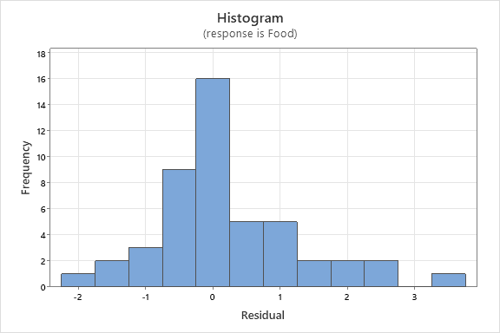

There is an approximate bell shape in the histogram, therefore residuals are assumed to be